**Exercises on High Voltage Engineering (Mar 6, 2025):**

**Exercise 1-14:** The following figure shows the relationship between the initial discharge voltage of the parallel plate electrode system and the gas pressure, so which gap distance *d*1 or *d*2 is larger than the other?

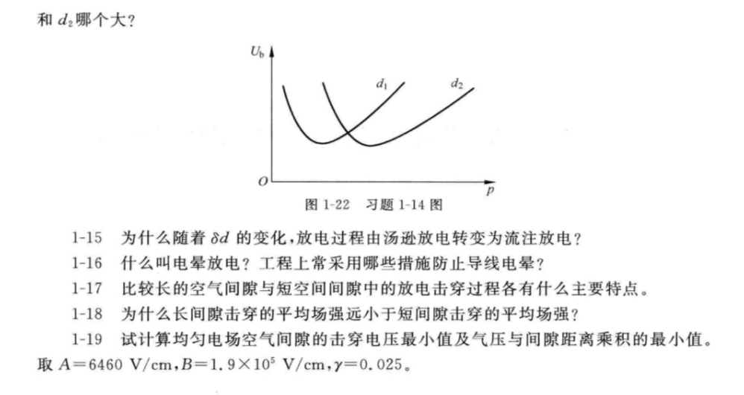

d1较大。因为根据巴申定律，同一个介质下Ub随pd变化的函数，故若以pd为横坐标，两系统应重合。而d1所在线在d2的左侧，故d1较大。

**Exercise 1-15:** Why does the discharge process change from Townsend discharge to streamer discharge with the change of *δd*?

当δd较小时，气压较低或间隙距离d较小，电子崩中的电子更容易到达阴极，而不是被气体分子吸收形成负离子。此外，金属表面的光电离比气体光电离更容易发生。因此，在δd较小的情况下，放电过程主要由电子崩主导，表现为汤逊放电。

然而，当δd增大时，气压升高，气体分子密度增加，单位空间内碰撞电离产生的电子数量也随之增加。这导致电子被气体分子吸附形成负离子的概率增大。负离子相对于电子更容易与正离子发生复合，释放出大量光子。这些光子进一步引发气体光电离，产生新的电子，从而引发二次电子崩，形成流注。

**Exercise 1-16:** What is corona discharge? What measures are often adopted in engineering practice to prevent conductor corona?

电晕放电是指在极不均匀电场中，当电压达到一定水平时，在空气间隙完全击穿之前，曲率较大的电极（即高场强电极）表面附近会出现一层微弱的发光层，这种现象在暗处尤为明显，因其形似“月晕”而得名。为了抑制导线上的电晕现象，工程中通常采取以下措施：使用分裂导线、增大导线截面积或采用扩径导线，以降低导线表面的电场强度；同时，通过增大高场强电极的曲率半径或等效曲率半径，安装外屏蔽环，以及优化电极形状以增强屏蔽效果，从而有效减少电晕放电的发生。

**Exercise 1-18:** Why is the average breakdown field strength of long gap much smaller than that of short gap?

在长间隙放电过程中，当流注发展到一定长度时，大量电子会沿着通道流向电极，导致流注根部温度显著升高，从而引发热电离。热电离使得流注通道中的带电粒子浓度大幅增加，形成高导电性的等离子体通道。同时，先导的形成使得其前端电场强度显著增强，更容易继续产生流注。因此，即使在平均场强较低的情况下，长间隙也能发生击穿，这使得长间隙击穿所需的平均场强远低于短间隙。

**Exercise 2-1:** What are the main stages of lightning discharge?

低雷电放电的主要阶阶可分为先导、主放电和余光。

**Exercise 2-3:** The laboratory has a pair of copper spheres with a diameter of 50cm, and the sphere gap distance can be continuously adjusted in the range of 30~60cm. How many kV is the range of power frequency breakdown voltage for this sphere gap system?

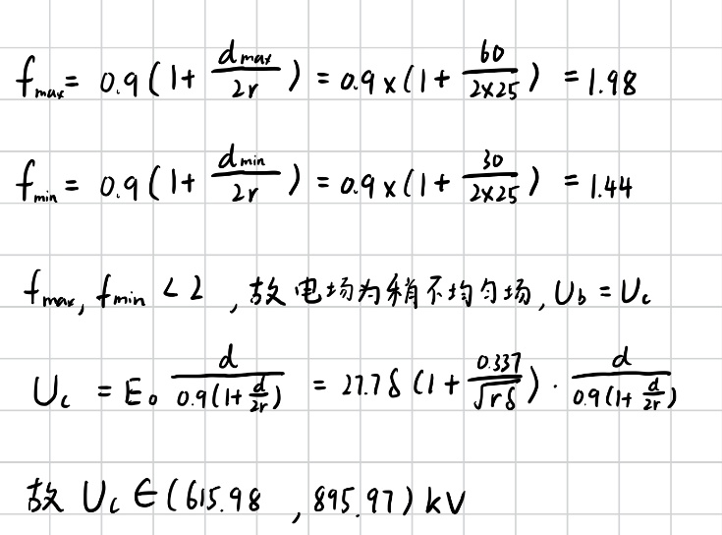

**Supplementary Exercise 1:** Under standard atmosphere conditions, how many kV is the breakdown voltage of positive and negative DC for the extremely non-uniform electric field air gap with a gap distance of 75cm? How many kV is the power frequency breakdown voltage?

查表有:

正极性: 330kV

负极性: 770kV

工频击穿: 280kV

**Supplementary Exercise 2:** There is a sphere-plane electrode system with sphere radius is *r* = 4cm and gap distance is *d* = 50cm. What are the corona inception stress *E*0, corona inception voltage *U*c and gap breakdown voltage *U*b respectively? If the gap distance is unchanged and only the radius of the sphere electrode *r* is changed to 1cm, then what is the approximate value of *E*0, *U*c and *U*b respectively?

一張含有 文字, 字型, 數字, 筆跡 的圖片

AI 產生的內容可能不正確。

**Supplementary Exercise 3:** Why the tip of grounded electrode may also produce corona? How to understand that there is no applied voltage in the Peek formula (Formula 1-35 of the textbook) for calculating the corona inception stress of conductor? How to explain the relation between applied voltage and conductor corona in Figure 1-14 of the textbook?

接地电极尖端产生电晕的原因

接地电极的尖端由于曲率较大，表面电场强度可能非常高，足以引发电子崩和电离现象。当电场强度达到一定程度时，会形成流注并产生放电现象，即电晕。

比克公式中外加电压的缺失

比克公式用于计算导线电晕起始场强，其不包含外加电压的原因是：对于特定形状的电极（如导线），其周围电场分布是固定的。外加电压仅影响电场中各点的幅值，而不会改变电场的分布规律。因此，电晕起始场强仅取决于电极的形状，与外加电压无关。

外加电压与导线电晕的关系

当外加电压较小时，导线表面场强较低，不足以引发电晕放电；随着电压增大，导线表面场强达到起始场强时，局部放电开始发生；若电压继续升高，导线附近场强进一步增大，最终会形成明显的电晕放电现象。因此，外加电压的作用是调节导线表面场强的大小，从而决定是否达到电晕起始条件。

**Supplementary Exercise 4:** There is a air gap parallel cylindrical with *r* = 5 cm, *d* = 50 cm, and a sphere-sphere air gap of *r* = 5 cm, *d* = 20 cm. Which gap has higher corona inception stress, the higher corona inception voltage and the higher breakdown voltage?

**一張含有 文字, 字型, 筆跡, 數字 的圖片

AI 產生的內容可能不正確。**

**Supplementary Exercise 5:**

(1) In the document on OHLs-1, the photos of a 500kV double-circuit tension small angle transposition tower are given on page 31&32. Please indicate the upper right phase, middle right phase, and lower right phase of the right circuit marked in yellow circle on page 31&32 are turned to which phase at the next tower in the distance of the photo after passing through this tower.

(2) In the document on OHLs-1, the photo of a transposition tension tower and cat head tower are given on page 33. Please indicate the top, left and right phases marked by red circle are turned to which phase of the cat head tower in the distance of the photo after passing this tower.

(1)黄色右上相、右中相和右下相分别换至右下相、右上相和右中相。

(2)上相、左相和右相分别换至左相、右相和中相。